**Architectural styles and design**

## **Conceptual architecture**

The conceptual architecture provides us with the initial architecture design and high-level domain responsibilities, based on the functional requirements provided by the stakeholders. Initially, we capture an overview of the entire application and then analyze the functional and nonfunctional requirements to identify key concepts and terms.

The view from the conceptual architecture is depicted in the image below, along with the AppUi with Navigation UI Logic that links to the Search and Business logic. It looks for the right location, accesses the database, gets the coordinates and information, and then returns that view.

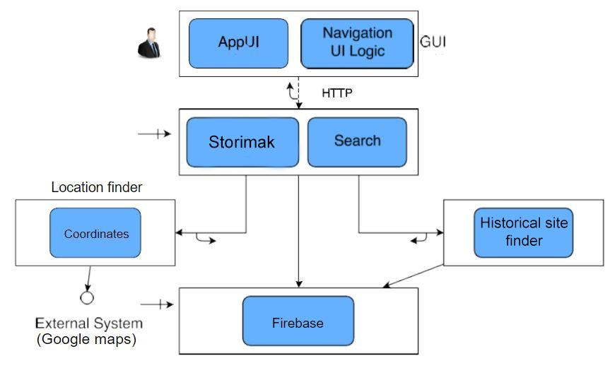

The next picture shows the behavior by moving through the system, that is, a behavioral model, i.e. behavioral research.

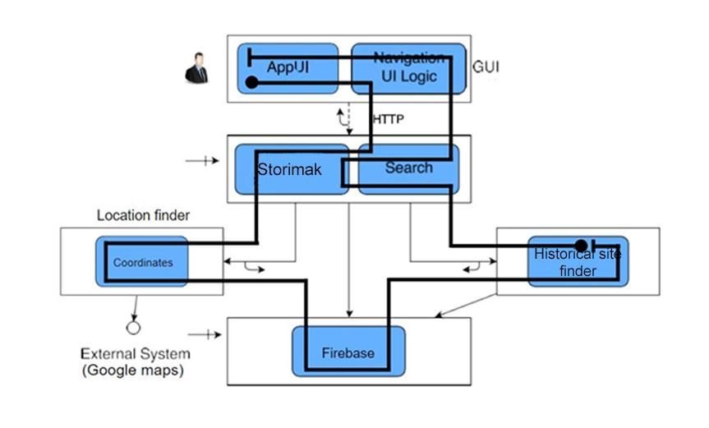

## **Execution architecture**

A system or computer's hardware and software components that enable the execution of programs or processes are referred to as having an execution architecture.

Execution architecture can significantly impact a system's performance, efficiency, and capabilities. Design choices in these architectural components influence how effectively a system can execute programs, handle tasks, and manage resources.

The following 2 images present diagrams of what the system's execution architecture looks like.

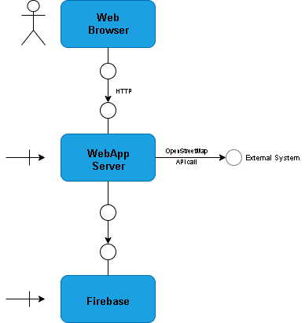

A view from another aspect.

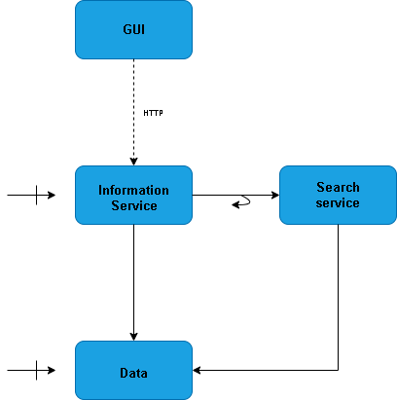

## **Implementation architecture**

Implementation architecture refers to the practical realization or actualization of a system or software design.

In our case, the Web Browser that will use the application will send an HTTP request to the server, where Tomcat intercepts the request and brings it to the appropriate servlet. The request is processed in the Spring Boot container whose application components make API calls to the database (Firebase) and to OpenStreetMap to display the location of the requested store/s.

The response through the servlet is taken to the web browser where the React application with the appropriate components displays the response as a map for the user with the located objects, as well as information and filters for further search.

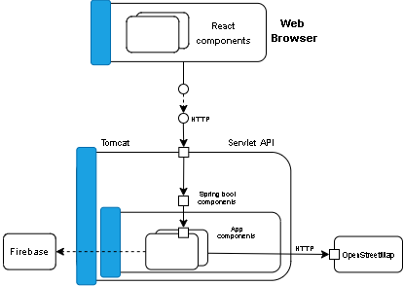

This figure below provides a more detailed look at the implementation architecture.

